THANH DO TRADING AND SOLUTION COMPANY LTD.,
Tel: 0916 513638; Email:info@thanhdogroups.com; Website: thanhdogroups.com
Product Name | Image | Item No. | Plastic Price | Brass Price | Alloy Price | SUS304 Price
Air vent plug | 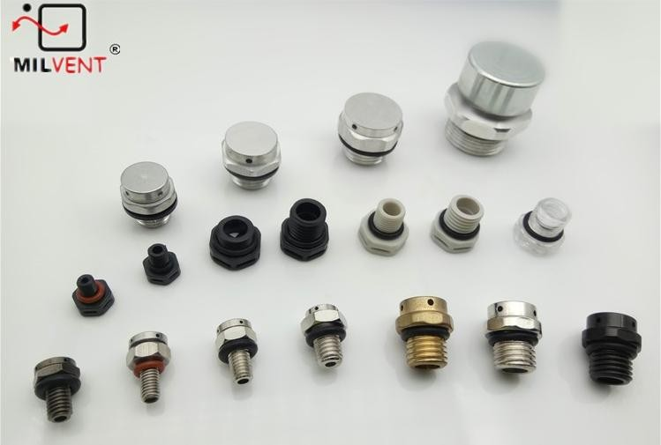 | M5x0.8-7 | $2.85 | - | - | -
 |  | M6x0.75-7 | $3.15 | - | - | -
 |  | M6x1.0-10 | - | $4.35 | $5.55 | $7.35
 |  | M8x1.25-10 | - | $4.50 | $5.70 | $7.50
 |  | M10x1.0-10 | $3.54 | $4.65 | $5.85 | $7.65
 |  | M12x1.0-5 | $3.60 | $4.80 | $6.00 | $7.95
 |  | M12x1.5-10 | $3.75 | $4.95 | $6.15 | $8.10
 |  | M16x1.5-10 | $4.05 | $5.10 | $6.45 | $8.55
 |  | M18x1.5-10 | - | $5.25 | $6.60 | $8.75
 |  | M20x1.5-10 | $4.44 | $5.40 | $6.75 | $8.85
Snap-in vent | 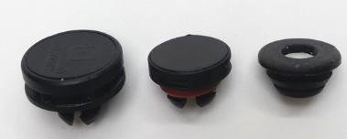 | AVS-200 | $3.75 | - | - | -
 |  | MIV-15 | $4.14 | - | - | -
 |  | MIV-006 tiny | $3.84(Rubber) | - | - | -

THANH DO TRADING AND SOLUTION COMPANY LTD.,
Tel: 0916 513638; Email:info@thanhdogroups.com; Website: thanhdogroups.com
Product Name | Image | Item No. | Plastic Price | Brass Price | Alloy Price | SUS304 Price
Surfboard Vent Plug | 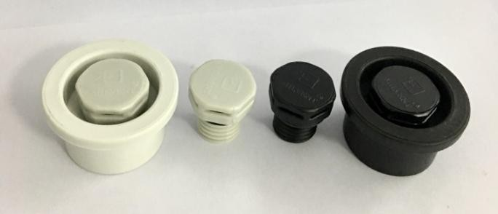 | M12x1.5 base | $4.95 | - | - | -
Venting Cable Gland | 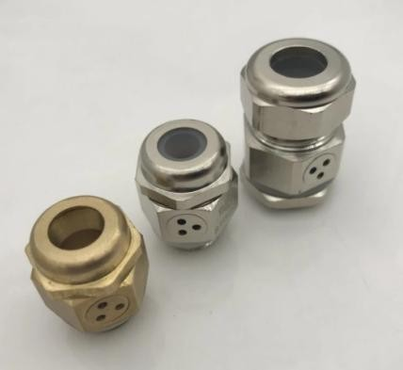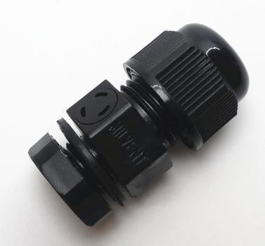 | M12x1.5/PG7 | $4.05 | $4.95 | - | -
 |  | M16x1.5/PG9 | $4.35 | $5.25 | - | -
 |  | M20x1.5/PG13.5 | $4.65 | - | - | -
 |  | PG16 | $4.86 | - | - | -
 |  | PG21 | $5.10 | - | - | -

